Object-Oriented Principles

# Objectives

* After completing this lesson, you should be able to do the following:
  + Define objects and explain how they are used
  + Associate objects so that they can communicate and interact via messages
  + Define classes and explain how they are used
  + Describe object-oriented (OO) principles: classes, objects, and methods
  + Describe the value of Reusable Software Components
  + Examine the OO model that is used in this course

# What Is Modeling?

* Models perform the following functions:
  + Describe exactly what the business needs
  + Facilitate discussion
  + Prevent mistakes
* Modeling and implementation are treated separately.
* Before coding can begin, the model must be correct.

# What Are Classes and Objects?

* A class:
  + Models an abstraction of objects
  + E:\Curriculum\templates\graphics\javaClass.gifDefines the attributes and behaviors of objects
  + Is the blueprint that defines an object
* An object:
  + Is stamped out of the class mold
  + Is a single instance of a class
  + Retains the structure and behavior of a class

# Object’s Attributes Maintain Its State

* + - Objects have knowledge about their current state.
    - Each piece of knowledge is called an *attribute*.
      * The values of attributes dictate the objects’ state.



Object: My blue pen



Attribute: Ink amount



Object: Acme Bank ATM Attribute: Cash available

# Objects Have Behavior

* An object exists to provide behavior (functionality) to the system.
* Each distinct behavior is called an *operation*.



Object: My blue pen



Operation: Write



Object: Acme Bank ATM Operation: Withdraw

# Objects Are Modeled as Abstractions

* A Java object is modeled as an abstract representation of a real-world object.
* Model only those attributes and operations that are relevant to the context of the problem.

Context: Product catalog

Real-world attributes/operations that you may want to model:

* Attributes: Model, manufacturer, price
* Operations: Change price

Real-world attributes/operations that you may *not* want to model:

* Attributes: Ink color
* Operations: Refill, change color, point, write

# Defining Object Composition

* + Objects can be composed of other objects.
  + Objects can be part of other objects.
  + This relationship between objects is known as *aggregation*.



A PC may be an object.

A PC may have a keyboard, mouse, and network card, all of which may be objects.

A PC may have a CD drive, which may be an object.

# The Donut Diagram

getName



setBirthdate

name address birthdate

getAge

getAge()

Message

getAddress setAddress

Client or sender

Person



# Guided Practice:

Spot the Operations and Attributes





# Collaborating Objects

* Collaborating objects work together to complete a task and form the basis of an application system.
  + All methods are defined within a class and are not defined globally as in traditional languages.
  + All objects are created from classes and contain all the attributes and methods of that class.
  + Objects must associate with each other to collaborate on common tasks.
  + Associated objects communicate by sending messages.

# Objects Interact Through Messages

* Objects communicate by sending messages.
* A sending object must be associated with or linked to the receiving object.
* The message sender requests the receiver to perform the operation that is named in the

message.

* This communication is similar to calling a procedure:
  + The sender calls a method of the receiver.
  + The receiver executes the called method.
* Calling a method is always in the context of a particular object:
  + myPen.write( ): Object-oriented programming
  + write (myPen): Traditional structured programming

# What Is a Class?

* A class is a template for objects.
* A class definition specifies the operations and attributes for all instances of that class.
* A class is used to manage complexity.



When you create *my blue pen,* you do not have to specify its operations or attributes. You simply say what class it belongs to.

# How Do You Identify a Class?

* Identify the common behavior and structure for a group of objects.
* Recognize a single coherent concept.
* Caution: A common misconception is the use of the words *classes* and *objects*

interchangeably. Classes *define* objects.

My blue pen ops: write, refill



attribs: ink amount, color of ink

Your blue pen ops: write, refill attribs: ink amount

# Comparing Classes and Objects

* Classes are static definitions that you can use to understand all the objects of that class.
* Objects are the dynamic entities that exist in the real world and your simulation of it.
* Caution: OO people almost always use the words *classes* and *objects* interchangeably; you must

understand the context to differentiate between the two meanings.

# What Is Encapsulation?

* Encapsulation hides the internal structure and operations of an object behind an interface.
  + A bank ATM is an object that gives its users cash.
    - The ATM hides (encapsulates) the actual operation of withdrawal from the user.
    - The interface (way to operate the ATM) is provided by the keyboard functions, screen, cash

dispenser, and so on.

* + - Bypassing the encapsulation is bank robbery.
  + Bypassing encapsulation in object-oriented programming is impossible.

# What Is Inheritance?

* + - There may be a commonality between different classes.
    - Define the common properties in a superclass.



Savings account

Account

Checking account

* + - The subclasses use inheritance to include those properties.

# Using the “Is-a-Kind-of” Relationship

* A subclass object “is-a-kind-of”



Pen

superclass object.

* A subclass must have all the attributes and behaviors of the superclass.

Account



Savings account Pencil

# What Is Polymorphism?

* + Polymorphism refers to:
    - Many forms of the same operation
    - The ability to request an operation with the same meaning to different objects. However, each object implements the operation in a unique way.
    - The principles of inheritance and object substitution.



Load passengers

# Architecture Rules for Reuse

* Write code that contains:
  + Events that can interact with your Java application
  + Properties that can be exposed
  + Methods that can be invoked
* Write code that supports:
  + Introspection or reflection
  + Customization
  + Persistence

# Engineering for a Black Box Environment

* JavaBeans follow the black box approach which enables you to:
  + Simplify something of arbitrary complexity down to a single

object that everyone can understand

* + Think of large systems as a collection of interconnected entities (black boxes) communicating via their interfaces

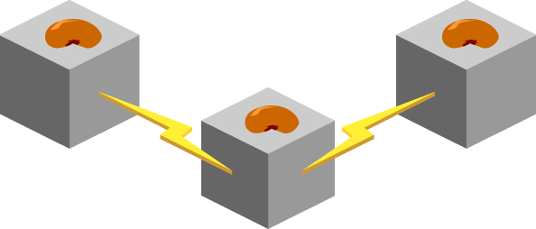

# Order Entry UML Diagram

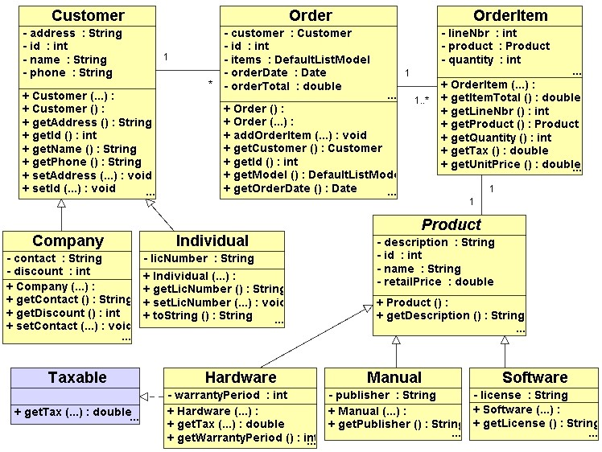

# Summary

* In this lesson, you should have learned the following:
  + An object is an abstraction of a real-world object.
  + A class is a template or blueprint for objects.
  + Classes form inheritance trees: Operations that

are defined in one class are inherited by all subclasses.

* + Polymorphism frees the caller from knowing the class of the receiving object.